**Problem 1:-** Write a Reusable PHP Function that can check Even & Odd Number And Return Decision

**Solution:**

<?php

function checkNumber($num) {

if($num % 2 == 0) {

return "Even";

} else {

return "Odd";

}

}

echo checkNumber(10);

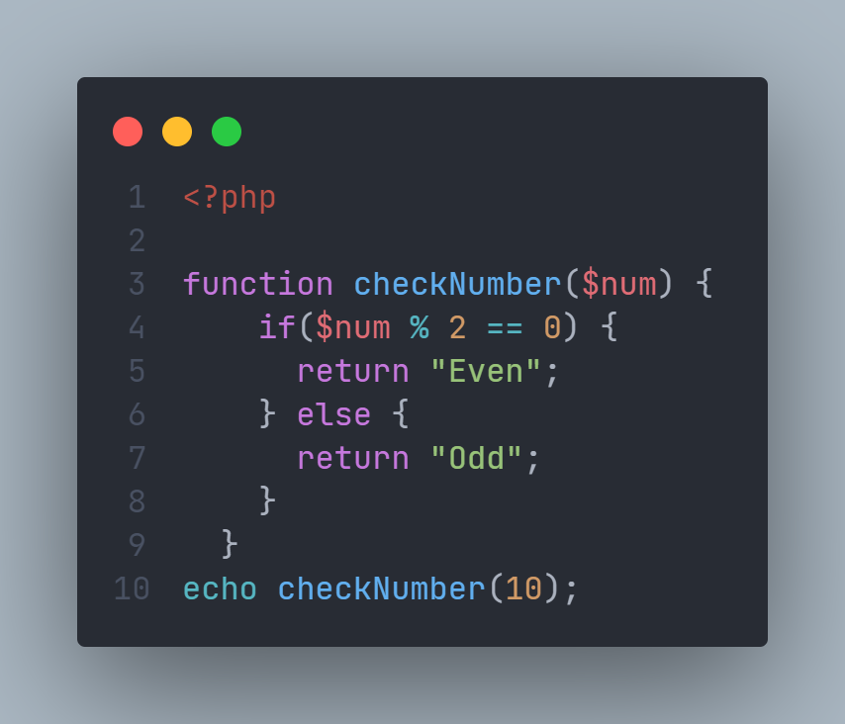

**Problem 2:-** 1+2+3...…….100 Write a loop to calculate the summation of the series

**Solution:**

<?php

$sum = 0;

for ($i = 1; $i <= 100; $i++) {

$sum += $i;

}

echo "The sum of the series is: " . $sum;

